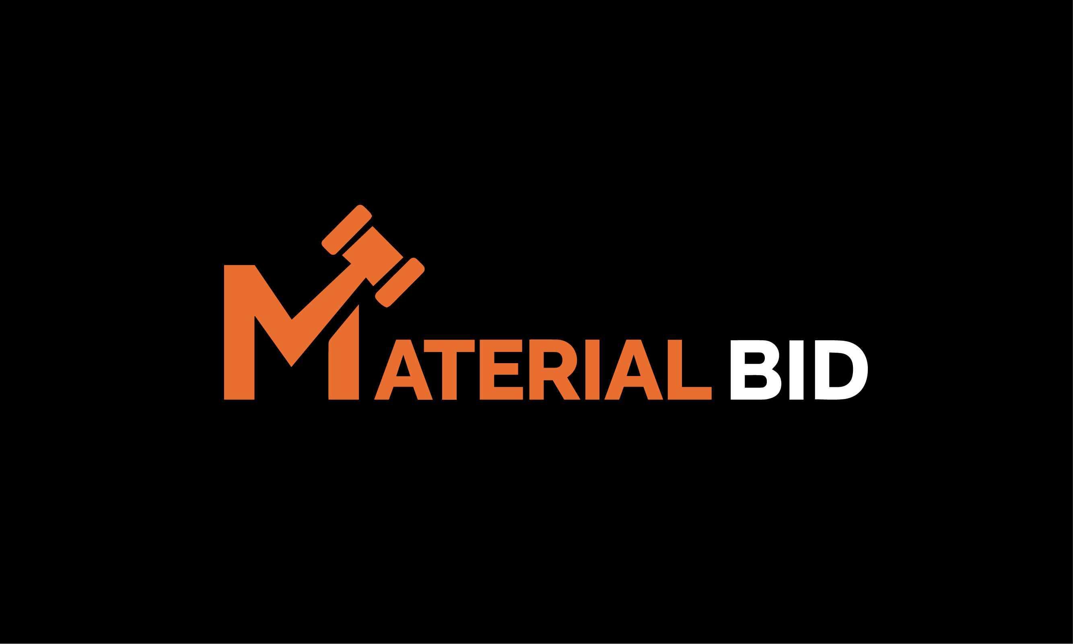

How to Succeed on MaterialBid
We want you to be successful — here are some tips on how to succeed on MaterialBid.

1. Create Your Account Before Auction Day
Register early. Verifying your account, adding payment details, and confirming your shipping info in advance means you're not scrambling when a lot you want opens for bidding.

2. Know What You're Bidding On
Every lot listing includes specs, quantity, condition, and photos. Read the full description before you bid — surplus and secondary material can have mill variances, cosmetic imperfections, or partial quantities that affect value. If something isn't clear, reach out before the auction closes, not after you've won.

3. Set a Max Price and Stick to It
Decide your walk-away number before bidding starts, based on your delivered cost (item price + freight). It's easy to get caught up chasing a lot — a firm ceiling keeps the deal profitable.

4. Remember: It's a Hard Close
MaterialBid auctions end at a fixed time — there's no extension if a last-second bid comes in. If you're serious about a lot, don't wait until the final seconds to place your best bid. Plan to be watching (or set alerts) as closing time approaches.

5. Plan Freight Before You Win, Not After
Buyers arrange their own shipping on MaterialBid. Get a freight quote — or at least a rough estimate — before you bid, so the total delivered cost is part of your decision, not a surprise afterward.

6. Bid on Multiple Lots to Improve Your Odds
If you need a certain grade or size of material, watch for it across several lots rather than pinning your hopes on one. Surplus inventory turns over regularly, so more opportunities are usually coming.

7. Have Questions? Ask Early
Contact our team before the auction closes with any questions about material specs, quantities, or pickup/freight logistics: (903) 488-4355.

Ready to start bidding? Browse current auctions or create your account to get started.

